**Practical 6 code**

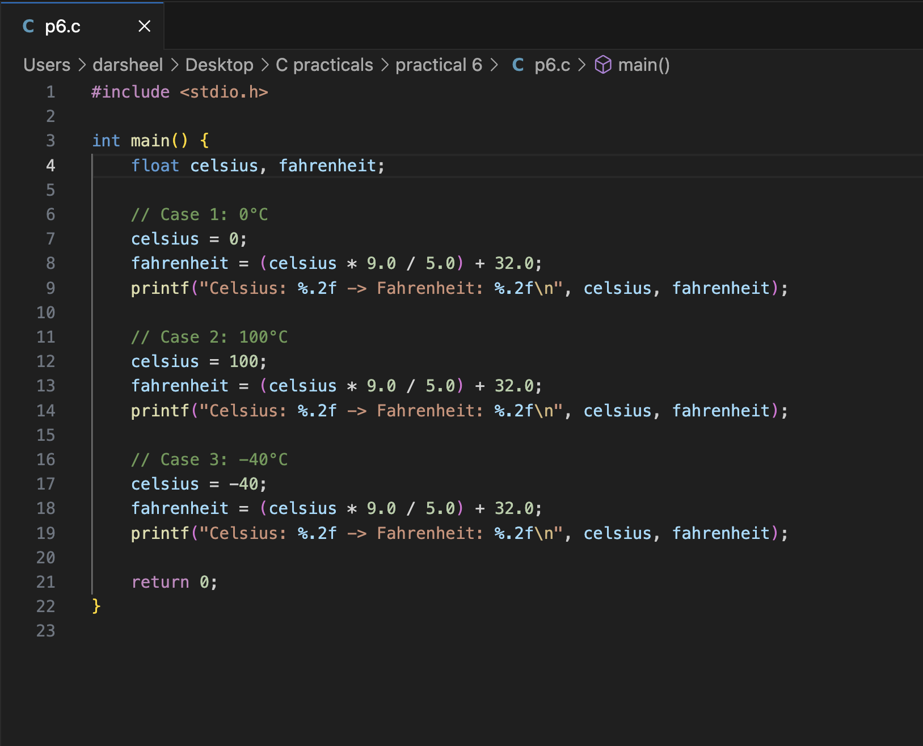

**Output of the code is:**

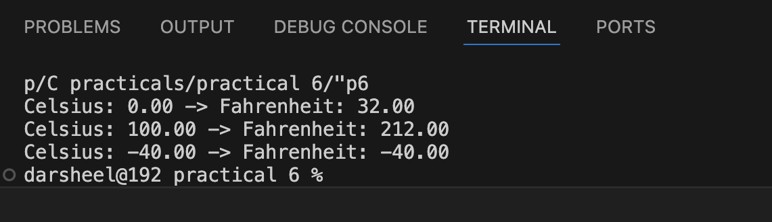**q**